Steps to Install Anaconda Navigator:

- Go to https://www.anaconda.com/download and then scroll down.
- Select your respective operating system. If you use Windows, then click on Windows.


- Once the download is complete, install it by clicking on the EXE file.

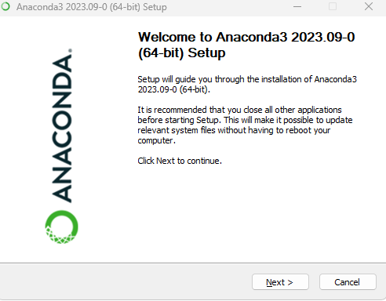

- Click Next.

- Read the licensing terms and click I Agree.

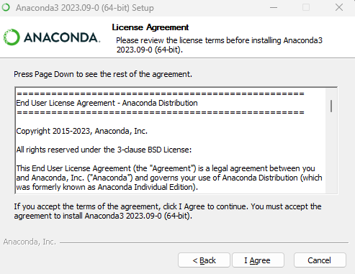

- Anaconda recommends choosing Install for Just Me, which will install Anaconda Distribution on the current user account.
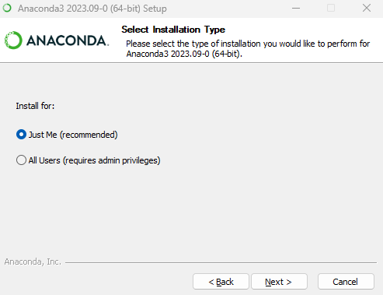

- Click Next.
- Select a destination folder to install Anaconda and click Next. Install Anaconda on a directory path that does not contain spaces or Unicode characters.
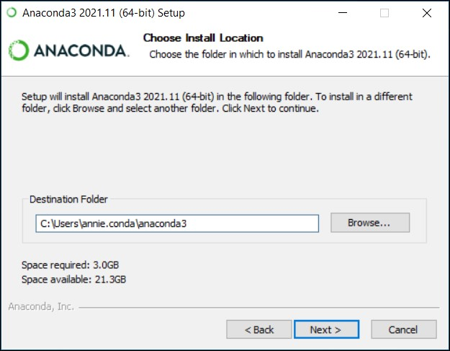

- Choose whether to add Anaconda to your PATH environment variable or register Anaconda as your default Python. It is not recommended to add Anaconda to your PATH environment variable since this can interfere with other software. Unless you plan on installing and running multiple versions of Anaconda or Python, accept the default and leave this box checked.

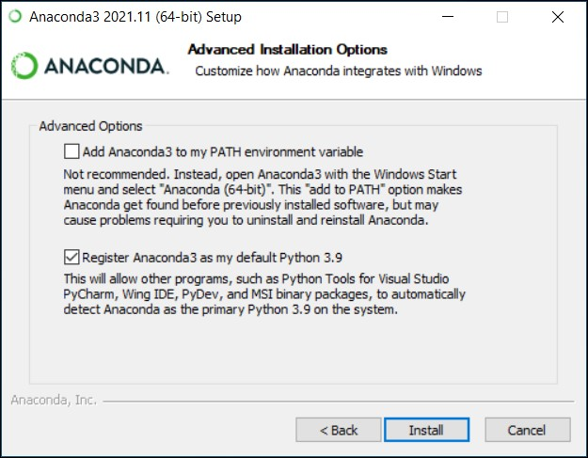

- Click Install. If you want to see the packages Anaconda installs, click on Show Details.
- Click Next.

After successfully installing it, you will see the Thanks for installing Anaconda dialog box:
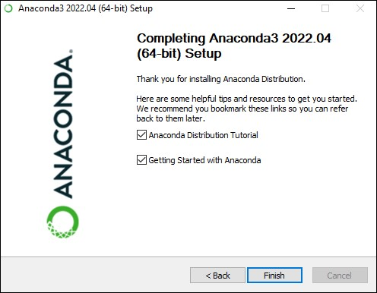
Note: Refer to the given link to visit the official installation website of Anaconda for more information: https://docs.anaconda.com/free/anaconda/install

